**Title:** Using Numpy

* Using Python list to create Numpy Array
* Create a 2-dimensional array
* Using Numpy features

**Objective(s):**

Upon finishing the lab, student will attain mastery of the following:

* Manipulating arrays using Numpy features

**Tools, Equipment and Materials:**

1. Personal Computer with Internet Access
2. Operation System with Installation of Python Software / Python IDE (e.g. PyCharm)

**Instructions:**

1. In this lab, you'll learn how use numpy to create and manipulate array.

**Import numpy module alias np**

1. Import numpy library and alias with the name np:



1. Create a python list and use it to create a numpy array

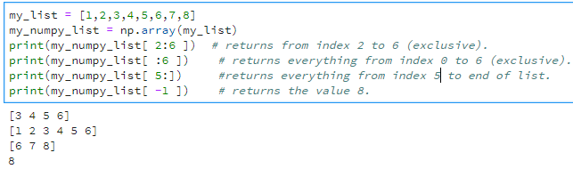

1. Type my_numpy_list to print the value in numpy list.

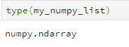

**Create 2-Dimensional Array**

1. Create a 2-dimensional array:

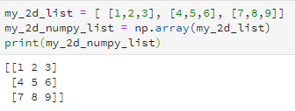

1. Using built-in arange () function to create a list of numpy array in arrange order

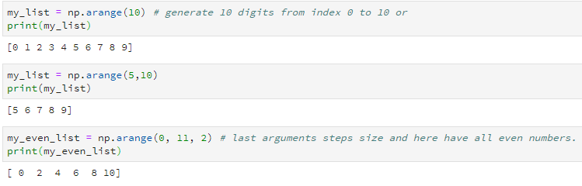

**Using Numpy Features**

1. To create a 1d arrays of values using zeros or ones:

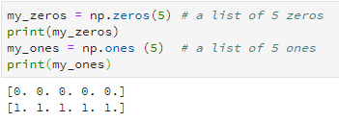

1. To create a 2d arrays of values using zeros or ones:

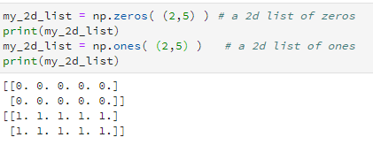

1. To generate a list of random numbers:

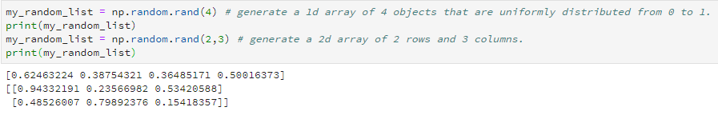

1. Using shape() function to convert 1d to 2d array:

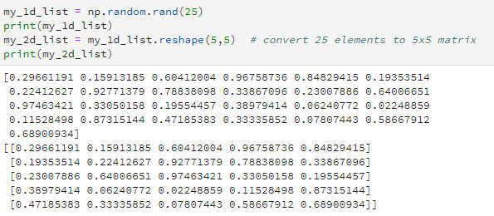

1. See the result by performing arithmetic operation on Numpy array:

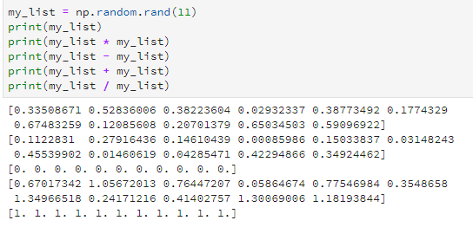

1. See the result by performing universal function on Numpy array:

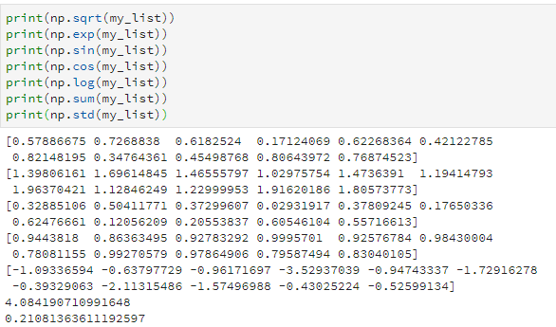

**Quizzes / Exercises**

1. You may proceed to do the following quizzes/ exercises in Datacamp (Introduction to Python - Function & Packages):
   1. Import package
   2. Selective import
   3. Different ways of importing
2. This is the last part of Datacamp quizzes/exercises for Introduction to Python which mean that you will get a certification of completion from Datacamp. You may proceed to do the following quizzes/ exercises in Datacamp (Introduction to Python - Numpy):
   1. Your First NumPy Array
   2. Baseball players’ height
   3. Baseball player’s BMI
   4. Lightweight baseball players
   5. NumPy Side Effects
   6. Subsetting NumPy Arrays
   7. Baseball data in 2D form
   8. Subsetting 2D NumPy Arrays
   9. 2D Artihmetic
   10. Average versus median
   11. Explore the baseball data
   12. Blend it all together
3. You may proceed to do the following quizzes/ exercises in Datacamp (Importing Data from Python – Part 1):
   1. Using NumPy to import flat files
   2. Customizing your NumPy import
   3. Importing different datatypes
   4. Working with mixed datatypes (1 & 2)

|  |  |
| --- | --- |
|  |  |

- END -